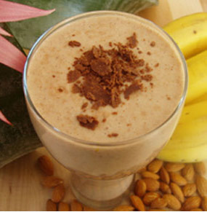

Eggnog Smoothie
Ingredients:
- 2 cups eggnog
- 1 banana
- 1 cup nonfat vanilla yogurt
- 1/3 cup of 2% milk
- 2 cups of ice
- Pinch of nutmeg
- Pinch of cinnamon
Blend until the banana is part of creamy texture. Trust me, this is eggnog smoothie is delicious!

